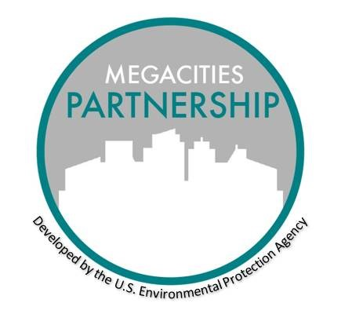

MEGACITIES PARTNERSHIP

Scoping and Inception Template

May 2021

Getting the Partnership Started

There are two phases of getting a Partnership underway, first determining if the location being considered is a right fit for the Partnership and subsequently understanding relevant information and context for making progress. We call these the scoping and inception phases, respectively.

The Scoping Phase initiates an in-depth conversation with local stakeholders and to better understand where the local stakeholders stand, in terms of capacity, air quality needs, motivation for action and therefore, whether a Megacities Partnership is viable. The Inception Phase takes the next step in forming relationships with the local partners and introduces them to the fundamentals of air quality management, analysis, and communications.

The key role of the Inception Phase is to identify gaps with the past or future air quality management efforts and begin discussing ways to address priority concerns. This work is documented in an Inception Report and Workplan, for which a separate template is available. It may be possible to combine the work of the Scoping Phase – focused on gathering key information - with the work of the Inception Phase - building a Partnership Team, introducing key concepts and beginning to develop a joint workplan, and possibly conducting a first capacity building workshop. This is one way that each Partnership can vary depending on the needs of each city.

Below are some questions that can guide these preliminary conversations and information gathering. In addition, the Capacity Building Template offers workshop ideas for the inception phase, if such a workshop is a right preliminary step in the Partnership.

SCOPING QUESTIONS

General:

1. What are your impressions of the severity of air pollution in your city?
2. What are the top environmental priorities within your government/city?
3. Is there interest/ability on the part of your organization or others to address air pollution issues?
4. What is your familiarity with short lived climate pollutants and their impact on both health and climate change?
5. What sort of capacity does your organization have to address air pollution?
6. Are you or your organization interested in participating in our project?
7. Would your organization have the capacity to devote resources (human and other- equipment) to this type of project? Describe.
8. Is your organization willing to work with other stakeholders in addressing air pollution issues?
9. Does your organization have the capacity to exercise leadership regionally on air pollution issues and is your organization willing to?

Levels of Air Pollution:

1. Are you aware of any air pollution studies, either ambient or emissions studies that would be helpful in assessing the extent of the air pollution problem? Any pollution and health studies that have been conducted?
2. Is there any existing or past air monitoring or emission inventory work that has taken place?
3. What type of industries are prevalent within the city?
4. Are you aware of any traffic studies or assessments of vehicle fleet? What do you think is the average age of vehicles? What is the fuel quality? Do you have a sense of the percentage of cars that have functioning catalytic converters or diesel particle filters?
5. Do you know roughly what the percentage is of diesel versus petrol?
6. What is the extent of solid waste open burning in the city? Do you know what types of materials are generally burned?
7. What are your impressions as to the most significant contributor to air pollution? (e.g. vehicles? Household biomass burning?)

Priorities:

1. How do the issues of air pollution and climate change compare with other environmental priorities (e.g. safe drinking water) or other priorities in general (for example, compared to economic development or other health concerns, e.g., malaria, HIV)?
2. Is there evidence of public concern about air pollution (anecdotal or otherwise)?
3. Is there anecdotal or other evidence that air pollution is impacting people’s health?
4. What current policies or AQ standards are currently in place? Is there current or pending legislation or regulations with regard to air emissions? Climate pollutants? If so, what is the level of enforcement? What sort of budget is allocated for this enforcement?

Organization’s Capacity:

1. At what levels of government are people working in this city? National, local, regional?
2. How many of your staff work on air pollution issues? What are the backgrounds of those that work on air and climate related activities? Do you have engineers and/or atmospheric scientists/meteorologists? Health scientists? Data analysts?
3. What is the capacity within local health departments? Is there collaboration with the National Health Ministry around air pollution and health issues?
4. What sort of monitoring or other equipment does your organization have that would be helpful for this project?
5. Do you think your staff would be able to devote enough time to ensure the success of this project?
6. Are there resources available to fund air quality mitigation strategies, either from within the government, outside funders, or the private sector?

Household Energy:

1. What types of fuel are used in household energy consumption in the city? Wood? Charcoal?
2. In the areas where household cooking occurs, what kind of insulation exists? Are the cooking areas typically open or closed?
3. What is your general impression of the household energy use and air pollution?
4. What are the typical stoves in use? Open or hibachi-type (grill)?
5. Are you aware of any studies that have been conducted on indoor air issues?

Laboratories:

1. What is your capability with regard to analyzing ambient air samples? Have you ever done this?
2. What sort of lab equipment do you have for analyzing air samples? Scales, microbalances, gas chromatographs?
3. Has there been a working relationship between external labs or universities and government?

Meteorology:

1. Do air inversions occur in the city? Do inversion conditions exist, such as mountains that would prohibit air flow?
2. Are there other regionally specific weather or climatic events that impact air pollution? (e.g. unusual or seasonal wind events, sea surface temperature-related events such as El Nino)
3. What is the level of humidity in the city? Average temperatures?
4. Is there capacity to do weather forecasting?
5. What is the relationship with the weather service/source for meteorological data?

International Government and Non-Governmental Organizations

1. Are there other countries or organizations (e.g., World Bank, UN Environment, WHO, GTZ, Global Alliance for Clean Cookstoves) working on environmental issues – now or historically? What are their priority work areas? Have you collaborated with them in the past or presently?
2. Has previous work resulted in relevant information on sources, emissions or optimal mitigation strategies?

Civil Society Partners

1. What is the general public understanding of air pollution, its sources and impacts?
2. Are there local community groups or organizations that are concerned about air pollution? Climate change? Environmental issues in general?
3. Has there been any stakeholder processes to identify environmental concerns?
4. What is the relationship between the government entities and civil society groups?
5. What is the process for public participation in environmental decision making?
6. What is the process for governmental communication with civil groups?